INTRO TEXT:
We wish to present here some startling scientific discoveries and accomplishments, in hopes that those of us with means will be moved to answer to the call of a noble effort.
Our cause is the development of a rapid and cost-effective deployment of the means for the healing of all cellular disease – a major concern to all of us – whether it is the dread social diseases of cancer and leukemia, or diseases of terror, such as anthrax, smallpox and Ebola virus.
In these materials, we set forth a chronology of scientific events and their natural conclusions that will enable the reader to track accumulative successes through history, earned by the world's most prominent physicists working in the fields of electrodynamics and healing. This is most dramatically demonstrated by the amazing story of Antoine Priore’ and his historic successful treatment of those afflicted with cancer.
We begin with a brief on Monsieur Priore’, so as to build on his and the successes of the many brilliant and dedicated others that have contributed in bringing to light our stunning and viable solution, the Porthole Healing Process.

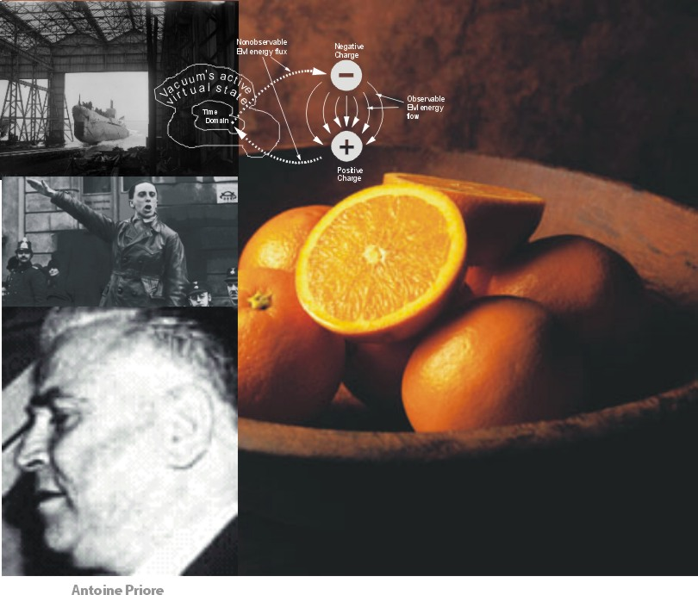
His story begins with a few oranges…
Antoine Prioré was born in Italy. He graduated from a small provincial school for electricity in Trieste, and became a Navy radar technician and operator. He later (after the Italian surrender in WWII) became a prisoner of the Nazis and was moved as a forced laborer to a submarine base in the vicinity of Bordeaux, France.
Rescued by the French underground, Prioré distinguished himself in their operations and was eventually decorated by the French government. Encouraged by his French resistance friends, such as Jacques Chaban-Delmas, who later rose to become the French Prime Minister, Prioré decided after the war to live in Bordeaux.
While in the Italian Navy, he had observed what to him was an exciting anomaly … a few oranges left in a room filled with electrical equipment had fallen into an assemblage where they seemed to have been preserved in the same fresh state they enjoyed when bought fresh off a fruit stand. Other oranges in the room, bought at the same time, were rotten and putrid.
Stunned by this observation, Prioré dreamed throughout the war of one day working out an electronic means of preserving foods in their fresh state based on what he surmised was a new and wholly unexplained principle. After the war, and working as an electrical repairman and movie projectionist, Prioré devoted his free time and resources to research.
Prioré began his experiments by exposing various animals to the radiation of an early invention. Meeting with some success, he began treating humans with cases that were judged to be hopeless, curing some of a malignant form of Hodgkin's disease, one case of cancer of the larynx, etc. His friend, Fournier, maintained a file of such human cases, but sadly, the file later was mysteriously lost. However, at Prioré's funeral, a small group of mourners was composed of people who had been cured in the late 1950s.
Prioré was successful in attracting the support of many credentialed and prominent professionals; to name only a few: Jacques Chaban-Delmas, Mayor of Bordeaux and later, Prime Minister of France; Professor Guerin at the French cancer institute at Villejuif; Fournier; Robert Courrier, Secrétaire Perpétuel to the Academy of Sciences and head of the biology section (later became President of the Academy of Medicine); Professor Raymond Pautrizel, an eminent parasitologist on the Faculty of Medicine at Bordeaux, awarded the first academic chair in France for immunology, and later headed a special unit on parasitological immunology; Admiral Pierre Emeury; as well as the French government to procure funds as well as clinical verification of his spectacular results.
Attempts to interest Bordeaux's leading physicists and cancer experts in the results of his new approach, however, were laughed off or dismissed with stony silence.
Unfortunately, because of the inventor's secretive nature and his reluctance (as well as inability) to disclose both the construction and exact means in which his invention worked, he also attracted many detractors in the medical and academic communities. Huge controversies raged from within these groups as well as the media.
Eventually, and after much turmoil, the French government backed the construction of a more powerful Prioré device. Professor Courrier had also sent a report on Pautrizel's behalf to the Nobel Committee in 1979. The M-600 machine was built but its huge tube functioned only about a week before it imploded. Meanwhile Pautrizel, working with a smaller machine, verified the utility of the Prioré ray on atherosclerosis. During the week or ten days that the machine was in operation, the results were formidable and were presented in notes to the Academy of Sciences by Pautrizel and his team in 1978.
Pautrizel then came under suppression himself with funding blocked and professional posts denied. Every one of Pautrizel’s collaborators saw their careers put in jeopardy, compromised, or broken. Prioré's doctoral thesis, backed by both Pautrizel and Nobel Laureate André Lwoff, was summarily refused by the President of the University of Bordeaux.
Pautrizel in final desperation turned to a journalist, Jean-Michel Graille, to tell the story. Graille researched for four years, publishing three long articles in Sud-Ouest France, and finally published a book, Dossier Priore: Une Nouvelle Affaire Pasteur (The Prioré Dossier: A New Pasteur Affair?). De Noel, Paris, 1984 (in French). An English version is now available online, through our Foundation.
From 1965 to 1980, the Prioré project spent about 20 million francs. Results were positively demonstrated, many of them sensational. Prioré suffered a debilitating stroke or similar complication in 1981 and died in May 1983.
The suppression of such a revolutionary discovery, notwithstanding that its technical methodology was misunderstood, remains a heinous example of scientific dogma blocking highly innovative research and results, as untold millions of human lives might possibly have been saved.
Picking up the scientific trail that was blazed by Prioré leads us first to early discoveries in electromagnetism and back to the present, to recent discoveries by today's dedicated quantum physicists … with revelations that are enormous to comprehend.
How did it work? …
If ever the proper use of electrodynamics to amplify the body's own cellular regenerative system is developed and employed, it will eventually be able to deal with most diseased conditions.
From a pure general relativity aspect, all the intricate patterns of forces that constitute any given “departure of the body from normal health state” form an “engine.” The technique used by the body’s cellular regenerative system – the healing system – is to electrodynamically pump (squeeze) the cell and all its tiniest parts. This forms an “anti-engine” or time-reversal of the disease engine, slightly amplified so it can “override” the disease engine. Gradually that causes the cell to reverse its condition back along the path it followed while developing the disease or disorder. That of course gradually reduces and eliminates the “disease engine” and the disease condition.
The first few decades of the twentieth century were a time of assimilation of electrodynamic, relativity and quantum mechanic breakthroughs, followed by a time of very practical governmental support for Euclidean physics and war solutions (missile trajectories, bomb sights, etc.), as major wars engulfed our countries. These efforts in science were all stunningly superseded by the application of quantum physics in 1945 at Nagasaki and Hiroshima, which then moved quantum physics out of the realm of theory into engineered reality.
As an example of this, in 1951 physicist and physician Robert Becker proved that cells could discard their hemoglobin coat and grow a nucleus, turning into the type of cell that makes cartilage, and again into the type of cell that makes bone, all within a fracture site … and by using very weak direct current. He had inadvertently created weak time-reversals in living cells in his treatments of bone fracture, regenerating cellular growth of cartilage and bone. But evidenced by his publications, and like Prioré, Becker could not understand the theory involved.
In spite of that, he showed that by “pumping” time-polarity-reversed electrodynamic waves into bone fractures, he was able to stimulate the body’s own internal mechanisms to provide healthy new growth. Recognized for his epochal healing work, Becker was nominated for the Nobel Prize.
Later, in (date) Novosibirsk, Russia, Dr. Vlail Kaznacheyev, the director of the Institute for Clinical and Experimental Medicine, experimented with isolated twin cell cultures and proved in approximately 15,000 tests that cellular diseases are emitted electromagnetically and can be absorbed successfully by target cells.
This demonstrated that patterned photon systems exist in biological systems. And that not only can a cell’s potential charge pattern be induced as disordered, but the opposite is true as well … if a continual ordered substructure exists as the input from an external electromagnetic scalar potential and imputed into a diseased cell’s potential, that potential will gradually “charge up” the cell with its healthy pattern.
Spectacularly, all living cells sort of “breathe in” the virtual state charge structure of their environment, as they “breathe out” their own internal virtual state charge structure.
Our bodies are limited by their ability to pump, but the use of longitudinal EM waves greatly amplifies the same process that the body uses. Which is what Priore did, but without anyone understanding the exact mechanism. The mechanism does not exist in standard electrical engineering, and all the electrical engineers on earth could not understand the Priore mechanism.
If that effort ever gets allowed by the scientific community and funded for development, a magnificent new medical healing modality will have emerged. Given that development, it would be easily able to cure biological warfare mycoplasma infection,AIDS, cancer, the biological warfare diseases such as smallpox, anthrax, Ebola virus, bubonic plague, etc.
So, where are we in all this?
Engines of and from all life forms on earth (and the physical universe) exist in the ambient vacuum potential. The Miller-Fox-Urey biogenesis experiments “kindled” new life forms from gasses, by amplifying living engines in and from their virtual state to our observable state, and so their masses were molded into physical states, determined by genetic blueprints.
In today's labs, human DNA can be inserted into animal cells and “persuaded” into proceeding as if it was fertilized; the cell forms, increases, and growth begins and continues. (At the quantum level, the robust “engine” carried by the human DNA is actually changing the available matter into human cells. This is the heart of the “cloning” process and is readily and publicly demonstrated.)
As the science of “engines” matures, physicians will be able to tailor engine combinations to not only provide non-chemical and non-invasive remedies for many, many diseases, but restore debilitated human spines, and eventually re-grow severed limbs. They will also be able to direct the body's “normal growth” to reduce and direct birth defects, genetic defects, etc.
Existing flaws in classical electromagnetism are now being dispelled by physicists such as Evans, Bearden, Wheeler and Nobelist, Feynman.
Much of the correction necessary in electrodynamics modeling is either done or underway. A new approach extenids the electrodynamics model to incorporate general relativity, producing a unified field theory. In this approach, spacetime curvature engines are perfectly natural and understandable, and can be directly modeled and engineered by theorists.
In short, electrodynamics theory has sufficiently advanced and is so robust that technology and engineering now offer to provide a leap forward to biochemistry and medical science.
Antoine Prioré's method of time-reversing cells back to their normal state, though in his time was not understandable in any terms, is now defined. It is seen now, as recognized then by world-class immunologist Pautrizel, that his invention was not, per se, specifically for healing cancers, but rather, for phase-conjugate pumping and restoring the body’s entire regenerative system and healing all diseased tissues by recalling cellular genetic memory to direct its patterns to return each cell to its original healthy state.
The Prioré method can, with certainty, be improved. A two-stage process is proposed. As studied by physicist Popp, et al., the master cellular control system controlling both the immune system and the cellular regenerative system (along with normal functions) and their histories resides as “inter-nested engine layers” in all cells … in all bio-organisms … in all living systems residing on the planet.
The first step in the process is, with engines, separate diseased cells from the central growth control and drive those cells back to their anaerobic state, to the time engine still resident in the sick cells, thereby time-reversing the cell and all its parts. Second, and concurrently, refresh the regenerative processes of the body and move the cells forward again on their time continuum to reach a healthy aerobic state.
These are well known processes and are all available in the scientific literature. To each of us, they represent a revolutionary “next step” for every advanced medical science. To our government, the processes are the very best long-term candidate for providing civil defense emergency aid for combating biological warfare, both cost effectively and mobilization ready – for both military and civilian casualties. (Additional social benefits are: lower medical costs and rejuvenation of the aging process.)
The Cheniere Foundation is dedicated to the advancement and overall development of quantum-level electrodynamic health sciences. Standing on the shoulders of many dedicated and spirited intellects, the Cheniere Foundation, with its associates and supporters from both science and lay communities, is the spearhead in an attack on many medical fronts, in its vigorous pursuit and successful fulfillment of the Porthole Healing Process.
___________________________________________________________________________

< SIDEBAR >

ENGINES
In 1955 an American scientist, David Bohm and his Israeli graduate student Hakir Aharonov, advanced proof that magnetic fields affect quantum properties in ways contrary to classical physics. Observed and confirmed by the scientific community in 1960, this hinted at a wealth of surprises concealed in quantum mechanics.
In Bohm's view, what goes on in all physical reality is the result of complex sets of patterns and changes in potentials at the quantum level, and all chemical, material, and mechanical effects are constituted and caused by interactions in the virtual state, by the patterns of virtual particle exchanges. This is accomplished by photons carrying robust organizing patterns to environments and “charging up” weaker nuclei until they breach the quantum threshold. The observable results are an emergence of that pattern as physical change. In medical applications, this appears as cellular “morphing” of diseased tissues into healthy tissues.
Typically, electromagnetic field potentials and waves reduce into sets of longitudinal, bi-directional electromagnetic waves (looking like FM radio signals). Since they are forceful, they create spacetime curvatures in local energy density spacetime (matter). These are components of general relativity mechanics infolded inside high-symmetry electrodynamics.
Curvatures are formed as space, filled with charged potentials, acts on matter, telling it which way to move. By the same token, matter reacts back on space, telling it which way to bend, or curve. All the levels of energy in space and all the dimensions of time-structures mold “spacetime” geometries, hence they are called curvatures.
By manipulating the longitudinal waves, spacetime curvatures can be changed and controlled for use as patterns to create changes in targeted cellular potentials. These patterns for local curvatures of spacetime are called “vacuum engines,” or “spacetime curvature engines.”
Our point is a new definition for disease emerges with quantum mechanics and electromagnetism, as does also the mechanism causing disease (Becker), and fortunately, the accompanying cures, which is the targeting of diseased tissue and pumping it with modulations of electrodynamic bi-waves, or, phase-conjugate (mirrored) materials, producing exact antidotal signals for specific cellular diseases. Production of these engines constitutes the Porthole Healing Process.
It is thereby conceivable that quick, inexpensive, non-debilitating, non-invasive cures can be developed for most dread, major diseases, including AIDS, arteriosclerosis, and cancer (such as was discovered and used by Antoine Prioré), and as important, biological warfare diseases of anthrax, smallpox and the Ebola virus.

(Insert engine figure and Bohm photo. All other discoveries to be moved to history chart.)

